**PAPER – III         PRACTICAL NO. : 04**

**AIM : WRITE A PROGRAM TO APPLY VARIOUS ENHANCEMENT ON IMAGE DERIVATIVES BY IMPLEMENTING GRADIENT AND LAPLACIAN OPERATION.**

**ROLL NO. : 02                                BATCH : M.SC PART-I**

**DATE : 17/10/22**

**CODE :**

import numpy as np

from scipy import signal,misc,ndimage

from skimage import filters,feature,img_as_float

from skimage.io import imread

from skimage.color import rgb2gray

from PIL import Image,ImageFilter

import matplotlib.pylab as pylab

import matplotlib.pylab as plt

from skimage.util import random_noise

from skimage.filters import gaussian

from scipy import signal

import numpy as np

def plot_image (image,title):

pylab.imshow(image),pylab.title(title,size=20),pylab.axis('off')

ker_x=[[-1,1]]

ker_y=[[-1],[1]]

im=rgb2gray(imread('elephant.jpg'))

im_x=signal.convolve2d(im,ker_x,mode='same')

im_y=signal.convolve2d(im,ker_y,mode='same')

im_mag=np.sqrt(im_x**2+im_y**2)

im_dir=np.arctan(im_y/im_x)

pylab.gray()

pylab.figure(figsize=(30,20))

pylab.subplot(231),plot_image(im,'original'),pylab.subplot(232),plot_image(im_x,'grad_x')

pylab.subplot(233),plot_image(im_y,'grad_y'),pylab.subplot(234),plot_image(im_mag,'||grad||')

pylab.subplot(235),plot_image(im_dir,r'$\theta$'),pylab.subplot(236)

pylab.plot(range(im.shape[1]),im[0,:],'b-',label=r'$f(x,y)|_{x=0}$',linewidth=5)

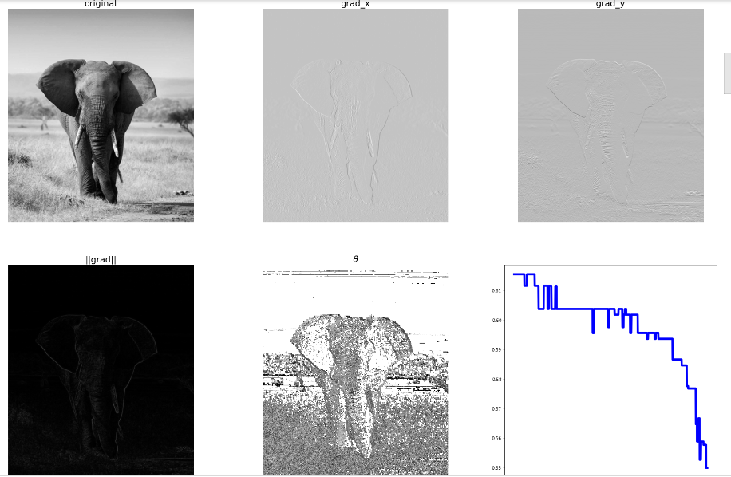

pylab.plot(range(im.shape[1]),im_x[0,:],'r-',label=r'$grad_x(f(x,y))|_{x=0}$')

pylab.title(r'$grad_x(f(x,y))|_{x=0}$',size=30)

pylab.legend(prop={'size':20})

pylab.show()

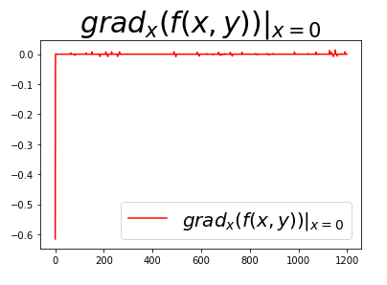

ker_x=[[-1,1]]

ker_y=[[-1],[1]]

im=rgb2gray(imread('elephant.jpg'))

#im=random_noise(im,var=sigma**2)

#im=gaussian(im,sigma=0.25)

print(np.max(im))

im_x=np.clip(signal.convolve2d(im,ker_x,mode='same'),0,1)

im_y=np.clip(signal.convolve2d(im,ker_y,mode='same'),0,1)

im_mag=np.sqrt(im_x**2+im_y**2)

im_ang=np.arctan(im_y/im_x)

plt.gray()

plt.figure(figsize=(10,15))

plt.subplot(321)

plt.imshow(im)

plt.title('original',size=30)

plt.axis('off')

plt.subplot(322)

plt.imshow(im_x)

plt.title('grad_x',size=30)

plt.axis('off')

plt.subplot(323)

plt.imshow(im_y)

plt.title('grad_y',size=30)

plt.axis('off')

plt.subplot(324)

plt.imshow(im_mag)

plt.title('||grad||',size=30)

plt.axis('off')

plt.subplot(325)

plt.imshow(im_ang)

plt.title(r'$\theta$',size=30)

plt.axis('off')

plt.subplot(326)

im=np.zeros((im.shape[0],im.shape[1],3))

im[...,0]=im_mag*np.sin(im_ang)

im[...,1]=im_mag*np.cos(im_ang)

plt.imshow(im)

plt.title(r'||grad||+$\theta$',size=30)

plt.axis('off')

plt.show()

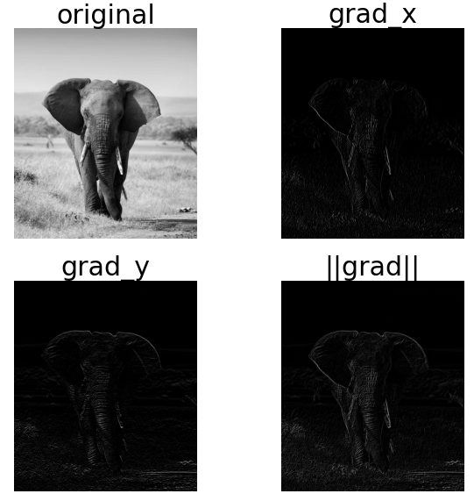

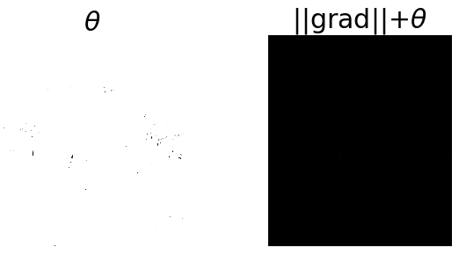

#Laplacian

ker_laplacian=[[0,-1,0],[-1,4,-1],[0,-1,0]]

im=rgb2gray(imread('cgvr.png'))

im1=np.clip(signal.convolve2d(im,ker_laplacian,mode='same'),0,1)

pylab.gray()

pylab.figure(figsize=(20,10))

pylab.subplot(121),plot_image(im,'original')

pylab.subplot(122),plot_image(im1,'laplacianconvolved')

pylab.show()

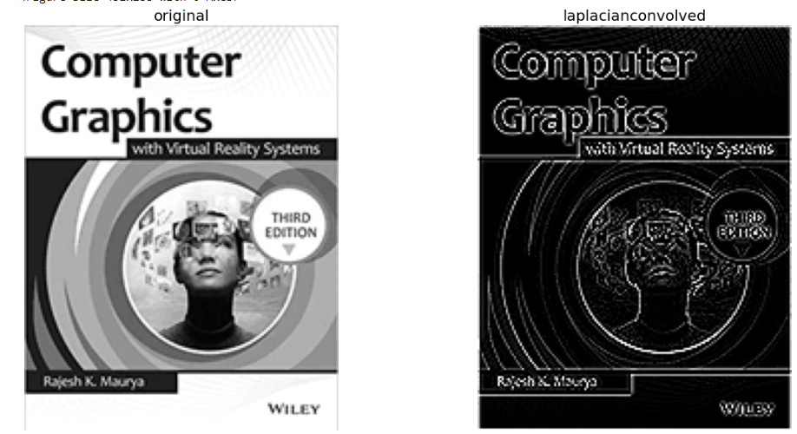

ker_x=[[-1,1]]

ker_y=[[-1],[1]]

im=rgb2gray(imread('board.PNG'))

sigma=0.25

sign=np.random.random(im.shape)

sign[sign<=0.5]=-1

sign[sign>0.5]=1

im=random_noise(im,var=sigma**2)

im=gaussian(im,sigma=0.25)

print(np.max(im))

im_x=signal.convolve2d(im,ker_x,mode='same')

im_y=signal.convolve2d(im,ker_y,mode='same')

im_mag=np.sqrt(im_x**2+im_y**2)

im_ang=np.arctan(im_y/im_x)

plt.gray()

plt.figure(figsize=(30,20))

plt.subplot(231)

plt.imshow(im)

plt.title('original',size=30)

plt.axis('off')

plt.subplot(232)

plt.imshow(im_x)

plt.title('grad_x',size=30)

plt.axis('off')

plt.subplot(233)

plt.imshow(im_y)

plt.title('grad_y',size=30)

plt.axis('off')

plt.subplot(234)

plt.imshow(im_mag)

plt.title('||grad||',size=30)

plt.axis('off')

plt.subplot(235)

plt.imshow(im_ang)

plt.title(r'$\theta$',size=30)

plt.axis('off')

plt.subplot(236)

plt.plot(range(im.shape[1]),im[0,:],'b-',label=r'$f(x,y)|_{x=0}$',linewidth=5)

plt.plot(range(im.shape[1]),im_x[0,:],'r-',label=r'$grad_x(f(x,y))|_{x=0}$')

plt.title(r'$grad_x(f(x,y))|_{x=0}$',size=30)

plt.legend(prop={'size':20})

plt.show()

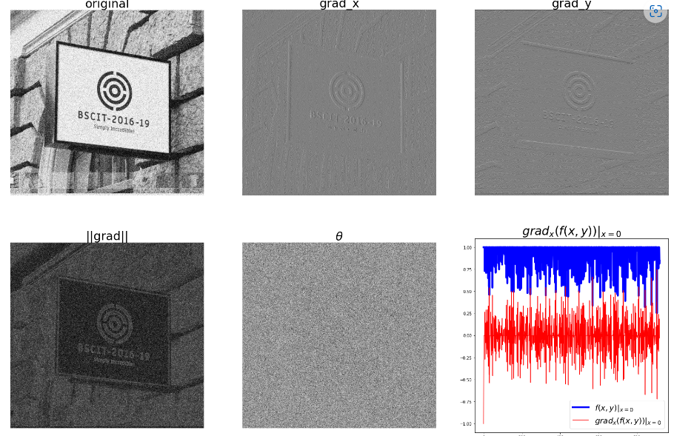

from skimage.filters import laplace

im=rgb2gray(imread('board.PNG'))

im1=np.clip(laplace(im)+im,0,1)

pylab.figure(figsize=(10,15))

pylab.subplot(121),plot_image(im,'originalimage')

pylab.subplot(122),plot_image(im1,'sharpenedimage')

pylab.tight_layout()

pylab.show()